**KALYANI GOVERNMENT ENGINEERING COLLLEGE**

Department of Computer Application



**Programming Concept with Python (MCAN-101) submitted for the fulfilment of CA2, Odd Semester, 2022**

|  |  |
| --- | --- |
| **Name:** | Rajendra Kumar Shaw |
| **Roll No.:** | KGEC/MCA/22/23 |
| **Stream:** | MCA 1st year 1st sem |
| **Subject:** | Programming Concept with Python [MCAN-101] |

**1.(a) Explain break and continue statements. When do we use those?**

**Continue Statement:**

It returns the control to the beginning of the loop. As the name suggests the continue statement forces the loop to continue or execute the next iteration. When the continue statement is executed in the loop, the code inside the loop following the continue statement will be skipped and the next iteration of the loop will begin.

**Syntax:**

Continue

**FLOWCHART:-**

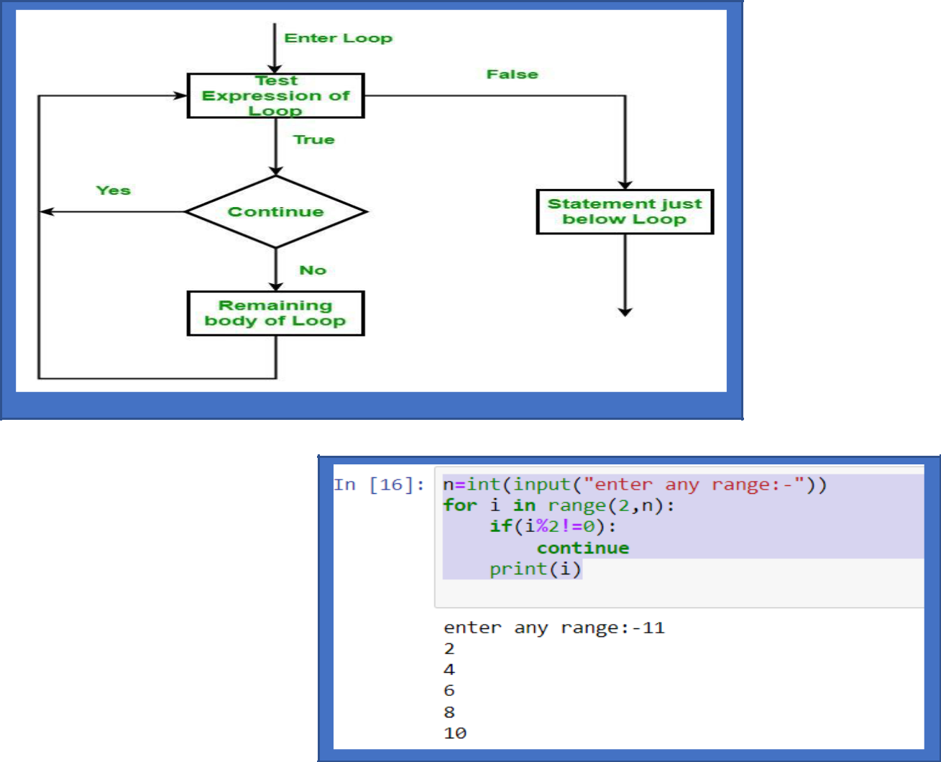

**Example:**

n=int(input("enter any range:-"))

for i in range(2,n):

if(i%2!=0):

continue

print(i)

**Break Statement:**

The break statement is used to terminate the loop or statement in which it is present. After that, the control will pass to the statements that are presentFlowchartafter the break statement, if available. If the break statement is present in the nested loop, then it terminates only those loops which contains break statement.

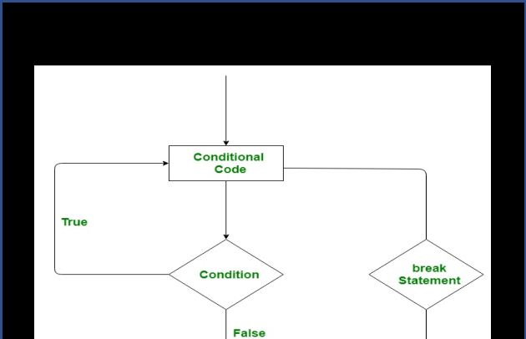

**Syntax:**

break

**example:**

n=int(input("enter any range:-"))

for i in range(0,n):

if(i==6):

break

print(i)

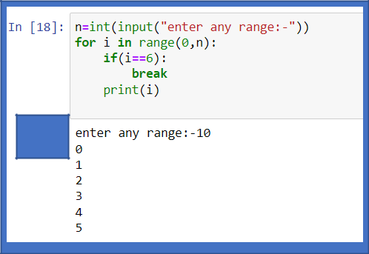

Output

**1.(b) What is nested loop? Explain with example.**

Python programming language allows to use one loop inside another loop.

**Syntax:**

for iterator_var in sequence:

for iterator_var in sequence:

statements(s)

statements(s)

The syntax for a nested while loop statement in the Python programming language is as follows:

**Syntax:**

while expression:

while expression:

statement(s)

statement(s)

**we can put any type of loop inside of any other type of loop. For example, a for loop can be inside a while loop or vice versa.**

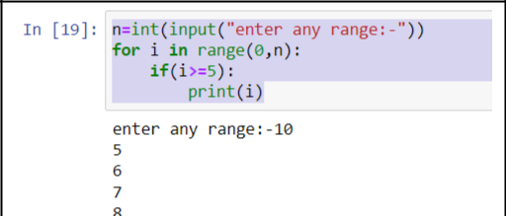

**Example:-**

n=int(input("enter any range:-"))

for i in range(0,n):

if(i>=5):

print(i)

1.(c) What is user defined function? How can we pass parameters in user defined functions?

User defined function:- When we create our own functions then functions are known as **user defines functions**.

1. In Python, def keyword is used to declare user defined functions.
2. An indented block of statements follows the function name and arguments which contains the body of the function.

**Syntax:**

def function_name():

statements

.

.

**Example:**

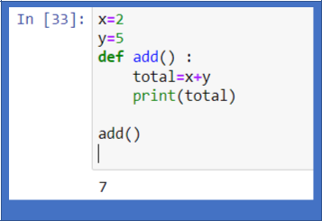

x=2

y=5

def add() :

total=x+y

print(total)

add()

**passing parameter in user defined function:-**

The function may take arguments(s) also called parameters as input within the opening and closing parentheses, just after the function name followed by a colon.

**Syntax:**

def function_name(argument1, argument2, ...):

statements

.

.

output

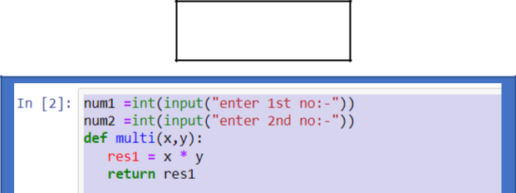

Example:-

num1 =int(input("enter 1st no:-"))

num2 =int(input("enter 2nd no:-"))

def multi(x,y):

res1 = x * y

return res1

print("The multiplication is", multi(num1, num2))

**2.(a) Illustrate the use of range() in python along with an example**.

**RANGE STATEMENT:-**

The Python **range() function** returns the sequence of the given number between the given range. The most common use of it is to iterate sequence type (**Python range() List**, string, etc. ) with for and while loop using python.

***Syntax:*** *range(start, stop, step)*

***Parameter:***

* ***start****: integer starting from which the sequence of integers is to be returned*
* ***stop:*** *integer before which the sequence of integers is to be returned. The range of integers ends at stop – 1.*
* ***step:*** *integer value which determines the increment between each integer in the sequence*

**example:-**

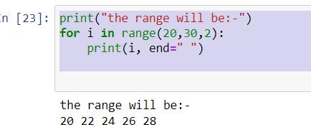

print("the range will be:-")

for i in range(20,30,2):

print(i, end=" ")

**2.(b) Write a python program to print table of numbers, taking number from user.**

n=int(input("ENTER ANY NUMBER"))

for i in range(1,11):

print(n,"x",i,"=",n*i)

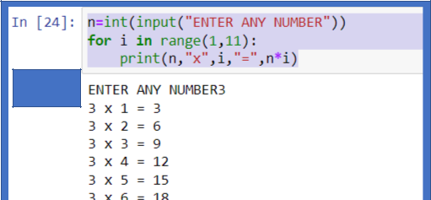

output

**2.(c) What is variable? Why do we use it? What do you mean by implicit declaration of variable?**

**Variable:-** Variables are containers for storing data values.

Python has no command for declaring a variable.

A variable is created the moment you first assign a value to it.

**How to use:-**

**Rules for creating variables in Python**

* 1. A variable name must start with a letter or the underscore character.
  2. A variable name cannot start with a number.
  3. A variable name can only contain alpha-numeric characters and underscores (A-z, 0-9, and a-z).
  4. Variable names are case-sensitive (name, Name and NAME are three different variables).
  5. The reserved words(keywords) cannot be used naming the variable.

**Example:-**

* integer assignment

age = 21

* floating value assignment salary = 20000.54
  + string assignment

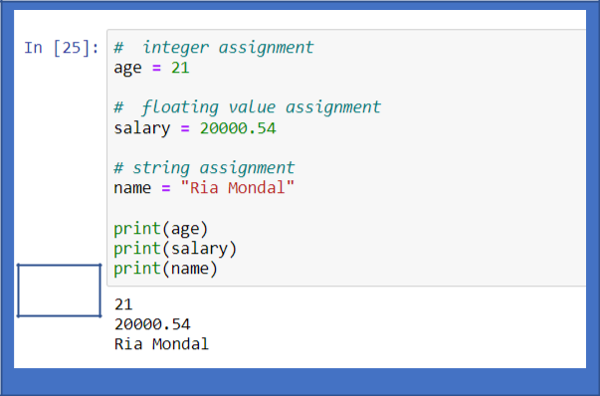

name = "Ria Mondal"

print(age)

print(salary)

print(name)

output

**implicit variable:-** Implicit variable declaration means the type of the variable is assumed by the operators, but any data can be put in it.

**Example:-** In C, in case of [int x = 5; printf (x-5); ]or[x = "anything"; printf(x-5);] returns a compile time error when you set x to test

but in Python, x = 5; print(x-5); x = "anything"; print(x-5); will "compile" (python doesn't compile, but it will run the program) and give you a runt time error when you try to subtract from the string.

